

CEREBROVASCULAR | Patient Details
<<Cerebrovascular>> | Name:<<Patient Demographics:Full Name>>
 | DOB: <<Patient Demographics:DOB>>
LEG - ARTERIAL | Addresss:<<Patient Demographics:Full Address>>
<<Leg - Arterial>>
 | Examination Required
 | Enter Text
LEG - VENOUS
<<Leg - Venous>> | Test Urgency <<Examination urgency>>
ARM - ARTERIAL | Reason for Examination
<<Arm - Arterial>>
ARM - VENOUS
<<Arm- Venous>> | Copy to
ABDOMINAL
<<Abdominal>>
 | Referring Doctor Date: <<Miscellaneous:Date (short)>>
 | Name: <<Doctor:Name>>
 | Address: <<Doctor:Full Address>>
 | Provider Number: <<Doctor:Provider Number>>
*Fasting instructions required unless diabetic.

HAMILTON 116 Everton Street NSW 2303
GATESHEAD Suite 2, Level 1 Specialist Medical Centre, Lake Macquarie Private Hospital, Sydney Street 2290
EAST MAITLAND Suite 14b, Level 2 Specialist Medical Centre 2, Maitland Private Hospital, Chisholm Street NSW 2323
TORONTO Suite 7a, Medical Centre 2, Toronto Private Hospital, Excelsior Parade NSW 2283
NELSON BAY 39 Stockton Street, Nelson Bay, NSW 2315

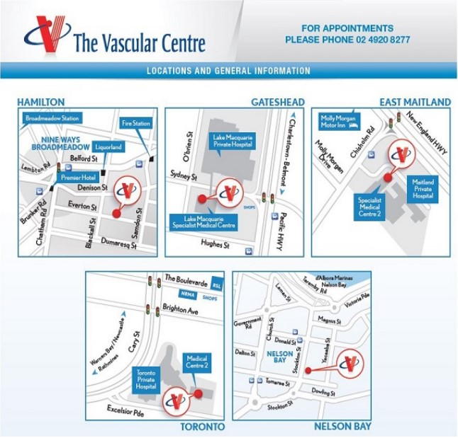

MY APPOINTMENT Date. . . . . . . . . . . . . . . . . . . . . . . . . . . . . . Time. . . . . . . . . . . . . . . . . . . . . . . . . . . . . . . .
OPENING HOURS Monday to Friday: 9am to 5pm
We appreciate you have a choice. Thank you for choosing The Vascular Centre.

THE VASCULAR CENTRE
p: 02 4920 8277 | f: 02 4942 3199 | e: info@thevascularcentre.com.au | www.thevascularcentre.com.au
HAMILTON 116 Everton Street NSW 2303
GATESHEAD Suite 2, Level 1 Specialist Medical Centre, Lake Macquarie Private Hospital, Sydney Street 2290
EAST MAITLAND Suite 14b, Level 2 Specialist Medical Centre 2, Maitland Private Hospital, Chisholm Street NSW 2323
TORONTO Suite 7a, Medical Centre 2, Toronto Private Hospital, Excelsior Parade NSW 2283
NELSON BAY 39 Stockton St, Nelson Bay, NSW 2315
ABN 35 975 837 147

